**Designing the Shop’s Shoe Display Areas**

The design of the shop was inspired largely by shop designs found online. One such inspiration is contained in the figure below. A scene was developed containing a shoe display wall and an display island

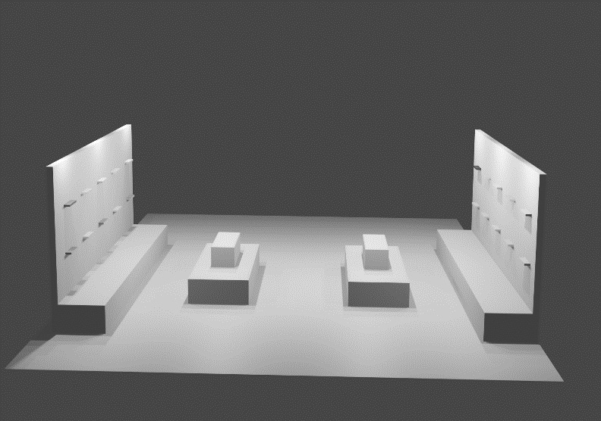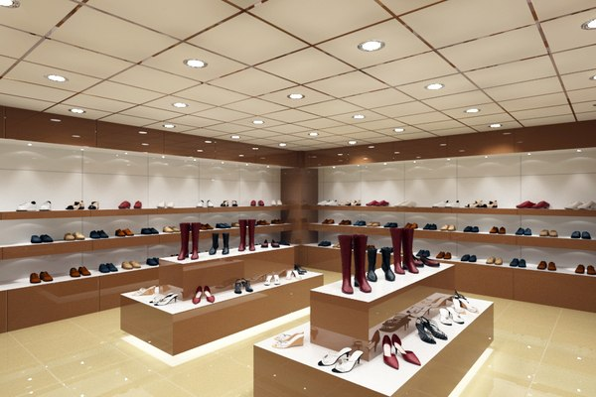

**Extra Feature – Shop Music**

The addition of shop music into the VR environment helps to set the tone within the scene, which enhances the users overall experience interacting with the environment. The music in this scene enhances immersion by stimulating the sense of hearing, which is an important feature of virtual environments. Royalty free music was sourced and placed in the environment using an AudioStreamPlayer node. Overall, music can significantly impact the atmosphere and experience of the shop environment, creating a more engaging and memorable experience for visitors.